Assignment 08

Section 01:
- Considering the Code Below, Write Down the Body of all listed methods, properties, and the constructor:

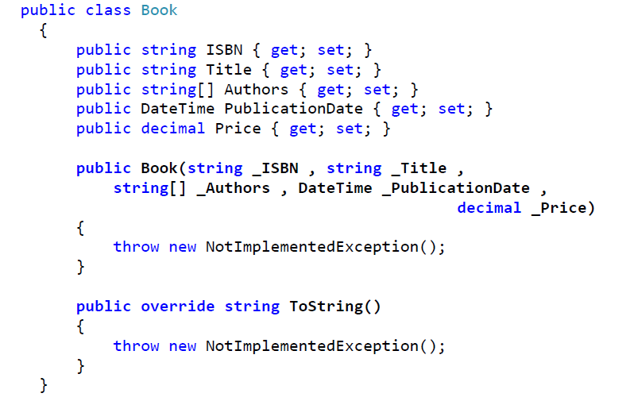

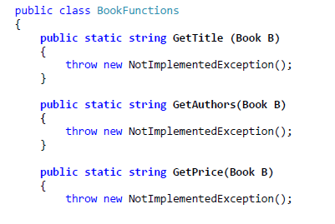
}
}

- You need to parameterize the ProcessBooks function to accept BookFunctions Methods using the following cases:
- Create a user-defined delegate with the same signature as the methods that exist in the BookFunctions class.
- Use the proper built-in delegate.
- Anonymous Method (GetISBN).
- Lambda Expression (GetPublicationDate).

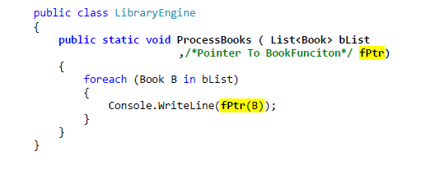

Section 02: C# Delegates & Events — Assignment

Objective
Build a small Order Processing System that demonstrates your understanding of:
- User-defined delegates
- Func<>
- Action<>
- Predicate<>
- Events
- Lambda expressions
- Multicast delegates
Focus on understanding why each delegate is used, not just making the code compile.

Scenario
You are building a simple order-processing system.
The system should be able to:
- Calculate the total price of an order.
- Validate orders.
- Perform actions when an order is processed.
- Notify other parts of the application when an order is completed.

Part 1 — User-Defined Delegate
Create an Order class containing:
public int Id { get; set; }
public string CustomerName { get; set; }
public decimal Price { get; set; }
public int Quantity { get; set; }
Create a user-defined delegate:
public delegate decimal PriceCalculator(Order order);
Create at least two methods that match this delegate:
CalculateTotal
CalculateTotalWithDiscount
For example:
CalculateTotal:
Price × Quantity

CalculateTotalWithDiscount:
Price × Quantity - discount
Create a method:
CalculateOrderPrice(Order order, PriceCalculator calculator)
The method should use the supplied delegate to calculate the price.

Requirement
Call the method using different implementations:
CalculateOrderPrice(order, CalculateTotal)

CalculateOrderPrice(order, CalculateTotalWithDiscount)

Part 2 — Func<>
Replace one of your user-defined delegates with a built-in Func<>.
Use:
Func<Order, decimal>
Create at least two different calculations using lambdas.
For example:
(x) => x.Price * x.Quantity
and another calculation that applies a discount.
Create:
CalculateOrderPrice(Order order, Func<Order, decimal> calculator)
Demonstrate both calculations.

Question
In your own words, explain:
What problem does Func<> solve compared with creating a custom delegate?

Part 3 — Predicate<>
Add order validation.
Create a method:
ValidateOrder(Order order, Predicate<Order> validationRule)
The method should return whether the order satisfies the supplied rule.
Create at least three validation rules, such as:
Quantity > 0

Price > 0

Order has a customer name
Use lambda expressions:
order => order.Quantity > 0
etc.
Example:
bool valid = ValidateOrder(
order,
order => order.Quantity > 0);

Question
Why is Predicate<Order> more expressive here than:
Func<Order, bool>
even though both can represent a function that returns bool?

Part 4 — Action<>
Create a method:
ProcessOrder(Order order, Action<Order> action)
The method should execute the supplied action after the order has been processed.
Create at least three actions:
Print order information

Send a confirmation message

Write an audit message
For example:
Action<Order> printOrder = order =>
{
Console.WriteLine($"Order {order.Id} processed.");
};
Call ProcessOrder with different actions.

Requirement
Demonstrate that you can pass different behaviors to the same method without modifying ProcessOrder.

Part 5 — Events
Now the application needs to notify other parts of the system whenever an order is completed.
Inside an OrderService class, create an event:
public event Action<Order> OrderProcessed;
Create a method:
public void ProcessOrder(Order order)
After processing the order, raise the event:
OrderProcessed?.Invoke(order);
In the Program class, subscribe multiple handlers to the event.
For example:
Print a message
Send a notification
Write an audit message
Then:
orderService.ProcessOrder(order);
should cause all subscribed handlers to execute.

Part 6 — Event Subscription
Demonstrate both subscribing and unsubscribing:
orderService.OrderProcessed += Handler1;
orderService.OrderProcessed += Handler2;

orderService.OrderProcessed -= Handler1;
Verify that after unsubscribing, Handler1 is no longer called.

Part 7 — Final Application
Your final program should demonstrate this flow:
Order
│
▼
Validate Order
│
▼
Calculate Price
│
▼
Process Order
│
▼
OrderProcessed
│
┌─────────┼─────────┐
▼ ▼ ▼
Handler1 Handler2 Handler3
Your implementation should contain:

User-defined delegate
delegate decimal PriceCalculator(Order order);

Func<>
Func<Order, decimal>

Action<>
Action<Order>

Predicate<>
Predicate<Order>

Event
event Action<Order> OrderProcessed;

Lambda expressions
Use lambdas in multiple places rather than defining a named method for every operation.

Multicast behavior
Demonstrate multiple subscribers/handlers being invoked.

Constraints
- Do not use if/else to decide which calculation or behavior should execute.
- Do not create separate methods such as:
ProcessOrderWithEmail()
ProcessOrderWithSms()
ProcessOrderWithAudit()
Instead, pass the behavior using delegates.
- Use Func, Action, and Predicate where they make sense.
- Use an event for the order-completed notification.
- Keep your classes reasonably small and follow SRP.
- The application must run from a console application.

Questions — Answer in Comments or a README

Q1
What is the difference between:
PriceCalculator
and:
Func<Order, decimal>
?

Q2
What is the difference between:
Action<Order>
and:
Func<Order, decimal>
?

Q3
Why does Predicate<T> return bool?
What kind of problem is it designed to represent?

Q4
What is the difference between a delegate and an event?

Q5
Why can't external code normally invoke an event declared in another class?

Q6
What happens when multiple handlers subscribe to the same event?

Q7
Explain what this code means:
orderService.OrderProcessed += HandleOrderProcessed;
Break down the meaning of:
OrderProcessed
+
=
HandleOrderProcessed

Q8 — Challenge
Explain the difference between:
Action<Order>
and:
event Action<Order>
They both involve Action<Order>, so why would we use an event instead of exposing the delegate directly?

Bonus Challenge
Modify the application so that different pricing strategies can be supplied at runtime:
Normal Price
10% Discount
20% Discount
VIP Discount
The OrderService must not know how the price is calculated.
It should receive the pricing behavior through a delegate.
For example:
Func<Order, decimal> pricingStrategy
Then the caller decides which strategy to use.
The goal is to achieve:
OrderService
│
│ receives behavior
▼
Func<Order, decimal>
│
├── Normal pricing
├── 10% discount
├── 20% discount
└── VIP pricing
without modifying OrderService.

